

''EPIC WATCH''

Team 2 Mainio
- Mohamed Nuh
- Nana Assyne
- Sidhartha Yalavarthi
- Udhyan Timilsina

*
Goal
- Have a system that declare an area as an epidemic zone

Idea
- The occurrence in a community or region of cases of an illness, clearly in excess of normal expectancy.
- Normal expectancy within a time
  - An interface for the community to input the case by describing the symptoms, this is sent to the database
- one needs to distinguish an abnormal rise in cases from a usual seasonal increase. History is needed.
  - In the database if the cases send is more that the threshold (comparing the history) then the system send an alert message
to the authorities to declare the area an epidemic zone so that necessary action could be taken to remedy the situation
- An alert message is send back to the community informing them of the epidemic

Problem
- • Many people die due to the fact that they are not aware of a situation like Epidemic is in their area. This is due to the fact that there are no record so that some of these epidemic can be analysis

Solution
- Creating the web page application or SMS message application
- The system takes the data send by the user in the remote area and compare it with it records
- If the case is above the threshold then a message is send to the authorities
- The authorities then can declare the area an epidemic zone and necessary action takensend email back to the user with the
- If it is not available in system, then it will forward to the online doctor. He will forward the proper medical prescription.
- Specific groups who are interested in the situation are informed
- The record are keep for future analysis

Architecture
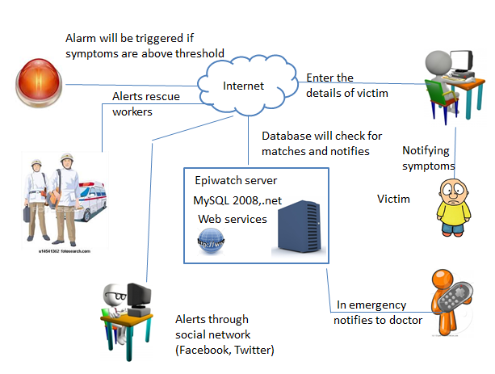

Screen shots
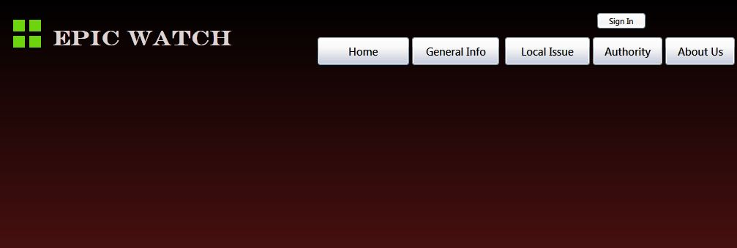
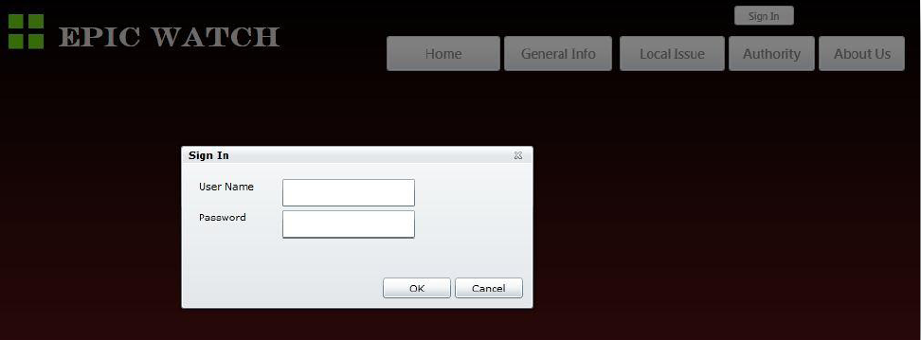
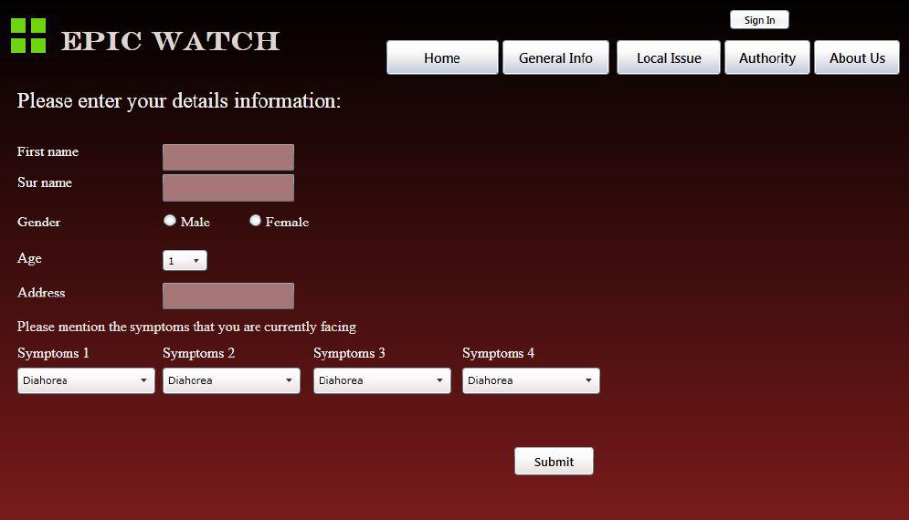

Tools and Technologies
- Microsoft Visual Studio 2010
- Microsoft Silver light
- Microsoft SQL Server 2008
- Microsoft Expression Blend 4


Project Artifacts
Source Code:
epidemic.rar
Presentation of Project
presentation.pptx
presentation.pdf
Report
epic_watch.pdf
Brochure
brochure.pdf

