

Team
- Mihai Iusan
- Camilo Cifuentes
- Alex Ovcharenko


Idea
The idea is to create a game that will challenge user's visual ability and it's fast reactions.

Motivation
- We all have times when we just get bored
- What can we do?

Answer
Create a game!!!
The game helps you to:
- kill time
- improve your reactions
- boosts your observation
- develop your competitive attitude
The choosed game is a board game!

Gameplay
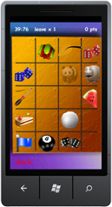 | FindIT: The goal is to find objects on a grid that are specified on the top of the screen in a specific time.The more objets the user finds, the more points he will get. If the user for mistake touch an incorrect image 5 seconds will be removed from the count-down clock. Every time the user makes a correct matching a random number of new icons will appear in the grid. When the time is 0 the user will see his score and he will have the option to submit it into the High score list.

User Interface
Next picture shows the different User Interfaces and the navigation between them.
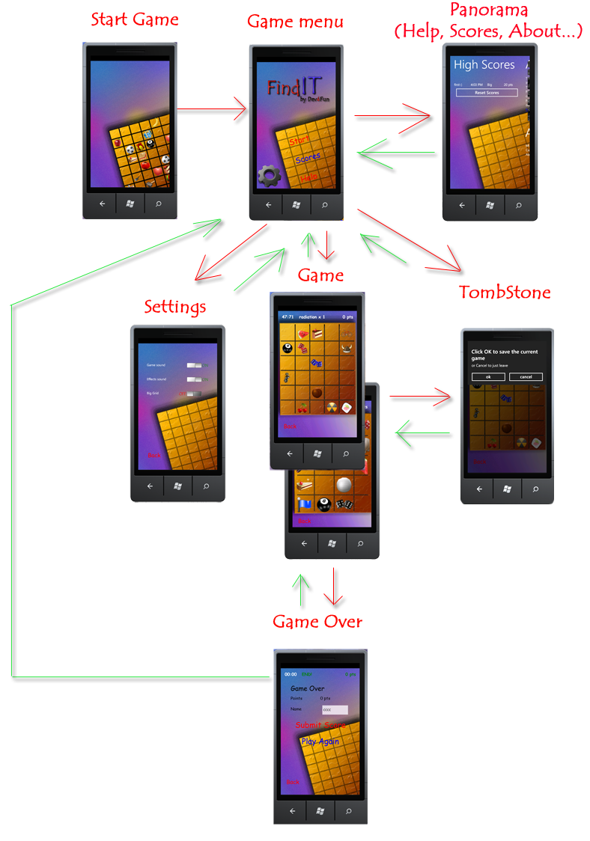

Technical Notes
For this project we focus on divided the application in “Pages” (view) and “Model”, the pages are basically the User-Controls and different UI elements, in the Model we have classes that handle different aspects of the application such as GrindMonitor (for the logic), ImageGenerator, SoundManager, Settings, ReadWrite (in the isolated storage), etc. These approach help us to divide also the team work (Design and Development).
We based our development in the following class diagram:
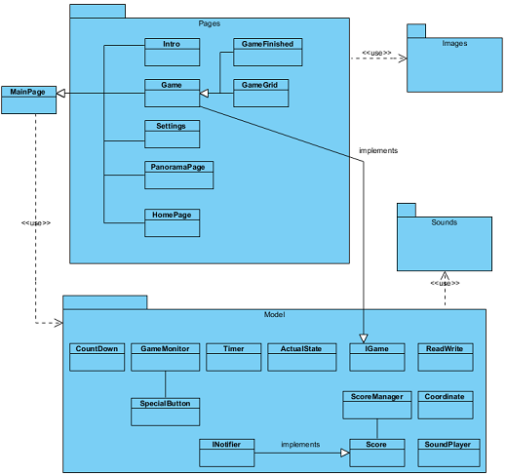Class Diagram
NOTE: for clarity, not all relationship are shown.

Project Artifacts
- Presentation dev4fun.pdf, dev4fun.pptx
- Source Code findit_final.zip
- Report findit_report.pdf
- Full Package findit_full_package.zip

Technologies


