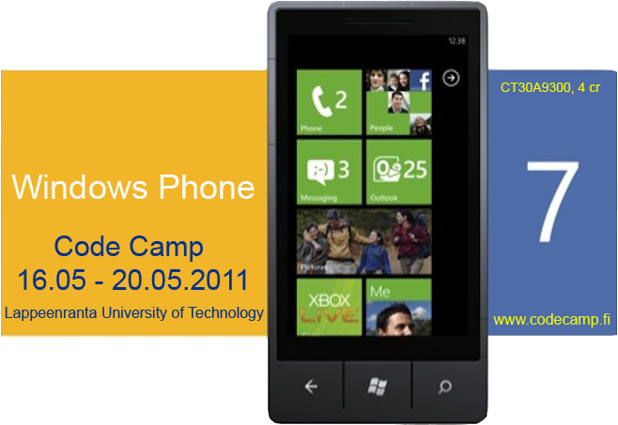
mobileproperty.rar

MobileProperty

Team 4
- Arttu Hanska
- Saeedeh Mehrouzi
- Nana Assyne
Problem
- We have a lot of item in today's life that require us to store some very important information about them.
Goal
- A WP7 Application That take a picture of an item,
- and allow you to add some information to the picture and store it,
- allow for browsing of the items detail later on.
Solution
- Create a WP7 app that can take a picture and allow for, other information to be stored.
How it works
- Start the app
- what to do (save an item or browse an item)
- Save an item
  - You take a picture of the item
  - Give it a name
  - it pup up what you can do on the item
    - Take a picture of the receipts
    - Input the data
      - price
      - guaranty start and end date
      - Manual (link to the manual)
    - location of the item *
  - Save the item
  - Close or return to previous main menu
- Browse an item
  - Select the item
  - Click on which item to view
  - Close or return previous main menu
Architecture
- This architecture illustrate how WP7 making used of mobile application,
- after taken a picture, it allow you to add important information to it
- and stored them in a local or dropbox or MS SQL server.
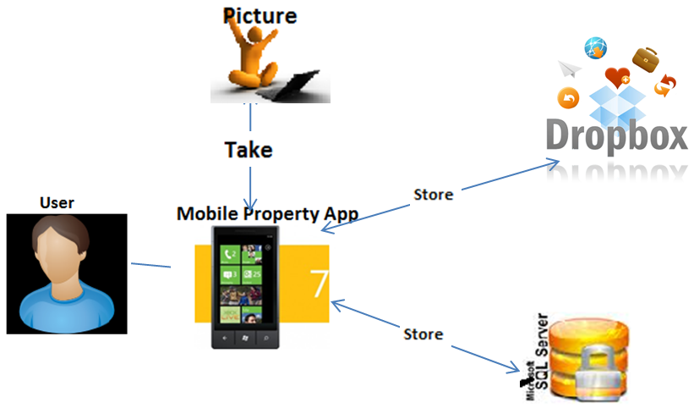
Use Case 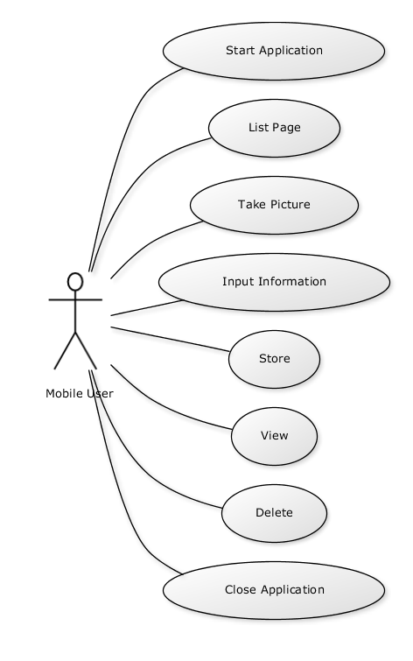
Screen shots 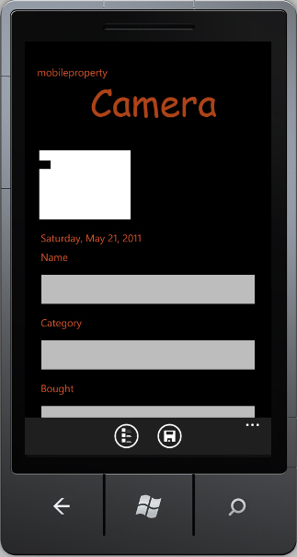 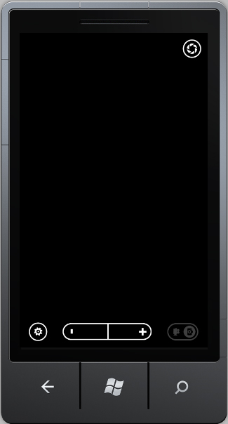 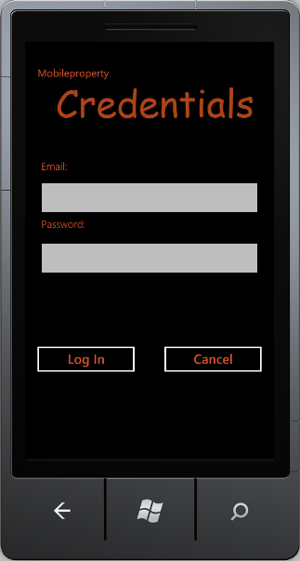 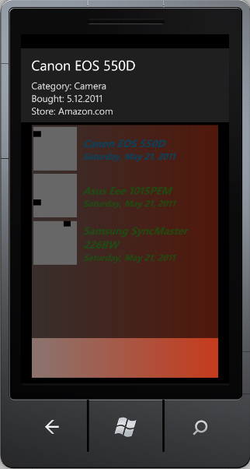 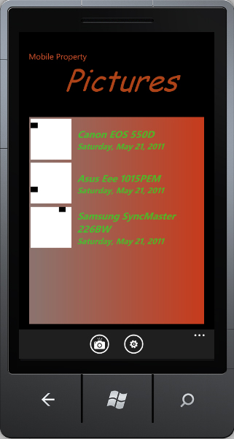 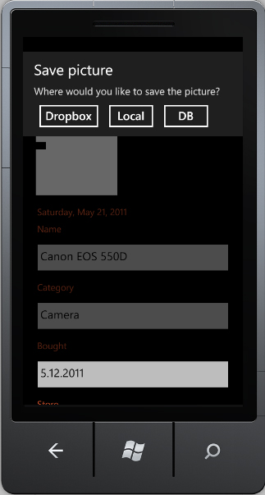
Tools and Technologies
- Microsoft Visual Studio 2010
- Microsoft Silver light
- Microsoft SQL Server 2008
- Microsoft Expression Blend 4

mobileproperty.pdf presentation1.pdf mobileproperty_pics.rar mobileproperty.rar

